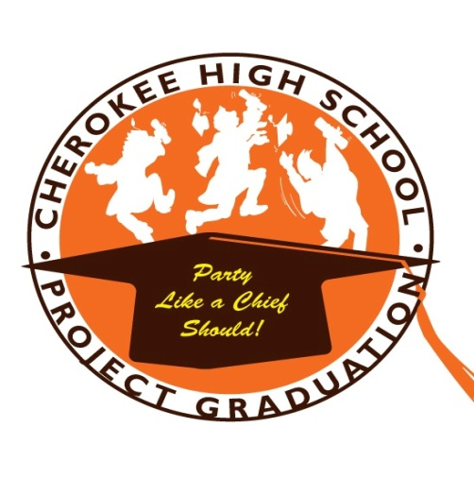

Cherokee HS Project Graduation
Last Dance 2022
120 Tomlinson Mill Road
Marlton, NJ 08053

Dear Senior and Parent/Guardian,

Project Graduation is hosting the Fifteenth Last Dance celebration for the Class of 2022 on Monday, June 6, from 6:00 to 9 p.m. in the Cherokee North Cafeteria. Please join us for this memorable evening!

Seniors, this is a way for you to say “Thank you” to the people who have helped you get to this point in your life. Seniors can bring one significant adult (ie, mother, father, stepparent, aunt, uncle, or grandparent.) Enjoy the evening in your casual/dressy attire, along with food, a DJ, dancing, and door prizes. The cost of this event is $50 per couple.

THIS EVENT SELLS OUT QUICKLY! Seating for this event is very limited, and is on a first-come, first-served basis. Registration is available in advance ONLY, and no registration will be available at the door. All registered names will be placed on a list; no tickets will be issued for this event.

Please return the bottom portion of this letter, along with your check payable to CHS Project Graduation, by Monday, May 23rd. Project Graduation volunteers will also be available at the Senior Class Trip Parent Meeting on Tuesday, April 5th and the Senior Prom Parent Meeting on Wednesday, April 27th.

Thank You,
Jenn Yocum
Last Dance Chairperson
theyocums@comcast.net
-------------------------------------------------------------------------------------------------
CHS Project Graduation Last Dance

Student Name: ______________________________ Guest:__________________________

Cell Phone #: ______________________________

Pay by Venmo to @cherokee-projectgraduation with the above information OR Please drop this portion to CHS Main Office with your check payable to CHS Project Graduation by Monday, May 23rd. Please write CHS Project Graduation Last Dance on the outside of the envelope.

